Landscape & Irrigation System Monthly Service Report

Client | AL Futtaim Engineering LLC | Facilities Management | AFM
Location | Chairman’s New Villa Al Badia | JOB CODE | 12A11159
Service Provided | Maintenance of Landscape & Irrigation system including Indoor Plants | Month | July 2026

ANNUAL PROACTIVE PLAN MAINTENANCE
Activities | Frequency | Jan. | Feb. | Mar. | April | May | June | July | Aug. | Sep. | Oct. | Nov. | Dec.
General cleaning/Removal of debris | Weekly | ● | ● | ● | ● | ● | ● | ● | ● | ● | ● | ● | ●
Checking of water availability | Daily | ● | ● | ● | ● | ● | ● | ● | ● | ● | ● | ●
Hand-watering of Pots | Weekly 3 times | ● | ● | ● | ● | ● | ● | ● | ● | ● | ● | ●
Indoor Plants Maintenance | Weekly | ● | ● | ● | ● | ● | ● | ● | ● | ● | ● | ● | ●
Lawn Mowing, Sweeping & Edging | Weekly | ● | ● | ● | ● | ● | ● | ● | ● | ● | ● | ● | ●
Pruning Shrubs & Hedges | Monthly | ● | ● | ● | ● | ● | ● | ● | ● | ● | ● | ● | ●
Pruning Groundcovers | Monthly | ● | ● | ● | ● | ● | ● | ● | ● | ● | ● | ● | ●
Weeding | Monthly | ● | ● | ● | ● | ● | ● | ● | ● | ● | ● | ● | ●
Soil Cultivation | Monthly | ● | ● | ● | ● | ● | ● | ● | ● | ● | ● | ● | ●
Trees (Crown Thinning, cleaning) | Bi-Monthly | ● |  | ● |  | ● | ● | ● |  | ● |  | ●
Fertilization | Quarterly |  | ● |  |  | ● |  |  |  | ● |  | ●
Irrigation Maintenance | Quarterly |  |  |  | ● |  |  | ● |  |  | ●
Irrigation Controller timing change | Quarterly | ● |  |  | ● |  |  |  |  |  |  | ●
Agriculture Pest Control | Half Yearly + As required |  |  |  | ● |  |  |  |  | ●
Lawn Aeration, Verti cutting | Half Yearly |  |  |  |  |  |  |  | ●
Lawn Top-dressing | Annual |  |  |  |  | ●
Trees (Crown Reduction) Hard-Pruning | Annual |  |  |  |  |  |  |  |  |  |  |  | ●

OPERATIONS PERFORMANCE
PPM TASKS Carried-out during the Month:
Activity | Frequency | Complete (✓) | Pending (✗) | Remarks
General cleaning/Removal of debris | Weekly | ✓
Checking of water availability | Daily | ✓
Hand-watering of Pots | Weekly 3 times + As Required | ✓ |  | Monday, Wednesday & Friday
Indoor Plants Maintenance | Weekly | ✓ |  | Monday, Wednesday & Friday
Lawn Mowing, Sweeping & Edging | Weekly | ✓ |  | Wednesday & Thursday
Pruning Shrubs & Hedges | Monthly | ✓
Pruning Groundcovers | Monthly | ✓
Weeding | Monthly | ✓
Soil Cultivation | Monthly | ✓
Lawn Aeration, Verti cutting | Half Yearly | ✓ |  | Aeration and Verti cutting activities will be carried out once the Chairman has vacated the premises.

EXTRA OR PENDING TASKS Carried-out during the Month
S/N | Description
01 | Application of Micronutrients (DISPER Complex Fertilizer) for bougainvillea has been carried out.
02 | Application of Chelated Iron (EDDHA Fe 6%) was carried out for Ixora near security entrance.
03 | Agricultural red soil top-up was carried out in the lawn areas to cover and level the existing bare patches.
04 | Application of Urea (46% Nitrogen) was carried out for Bauhinia purpurea in the Lawn Area to promote healthy Leaf growth.

REACTIVE MAINTENANCE TASKS Carried-out during the Month:
S/N | Description
01 | Application of Voliam Targo (4.3% Chlorantraniliprole + 1.7% Abamectin SC) along with Ridomil fungicide was carried out for lawn
02 | Application of Desert Energy (12-12-17+ 2MgO + TE) NPK fertilizer for the Delonix Regia tree has been carried out

OPERATIONAL CONSTRAINS
S/N | Incident Description | Status
01 | Irrigation water supply to the landscape has been shut down due to the non-availability of water in the lake. | Ongoing
02 | Access to the area near the villa for trimming the Vitex agnus-castus has been restricted. | Pending

OPERATIONS CONTACT DETAILS
Role | Name | Phone | Email
Operations Manager | Basem Adel | 052 848 0141 | basem@italianplanters.com
Project Engineer | Renin Amaldass | 052 484 0153 | renin@italianplanters.com
Supervisor | Afra Sayab Khan | 052 364 0501 | operations@italianplanters.com

OSH TRAINING
- Emergency rescue plan
- COSHH & spillage procedure
- Fire Safety
- Common falling object

KPI – SELF ASSESSMENT

S.No | KPI | MEASURE | TARGET | SELF SCORING | WEIGHTAGE | SUPPORTING DOCUMENTS
1. | PPM /Monthly/weekly/Daily Landscape Activities | Completion of PPM Tasks/Activities as per the schedule | 100% | 95% | 30% | PPM activities to be submitted in monthly report.
2. | Condition Auditing /Joint inspections | Completion of Defects in agreed timeframe | 100% | 100% | 20% | Defects and rectifications to be submitted in monthly report
3. | Outstanding Reactive/callout Maintenance activities.  Eg: Irrigation damages, Gap filling of areas, Missed out Landscape areas for servicing. | Response and Resolution as mentioned in SOW | 95% | 95% | 20% | Summary report for response and completion time to be submitted in monthly report
4. | Summary report for response and  completion time to be submitted in  monthly report | No. of incidents  Reported: None | 100% | 100% | 10% | All incidents to be recorded in  monthly report
5. | Manpower for Site Operations | Site Attendance report from security | 100% | 100% | 20% | Manhours in the monthly report
Total Score |  |  | 100% | 97%

ITP Representative: Basem Adel | AFM Representative: Nishant Khera
    Signature & Stamp:   | Signature & Stamp:
Date: 31.08.2026 | Date:

PHOTOGRAPHS

LAWN MAINTENANCE: Lawn Mowing, Edging, weeding and unclogging of sprinklers have been carried out
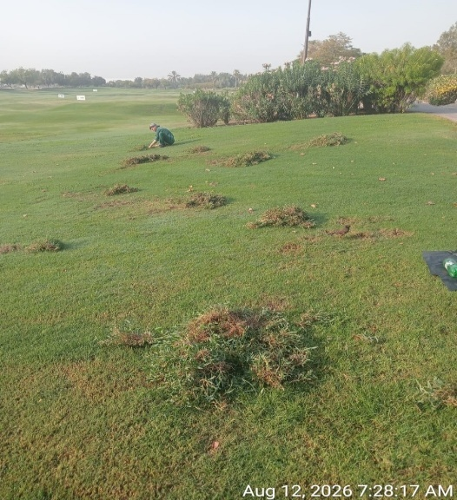 | 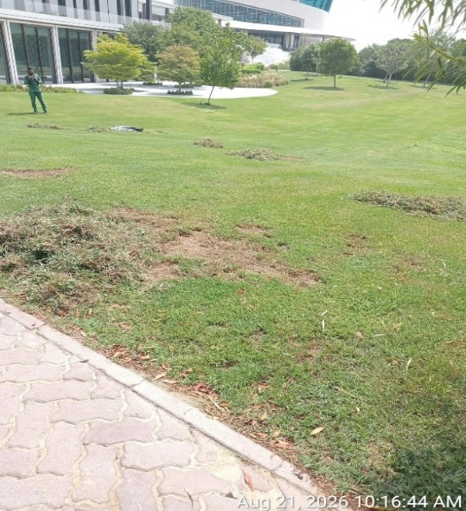 | 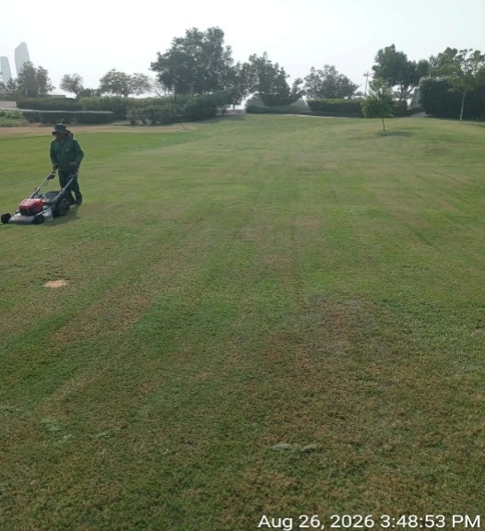
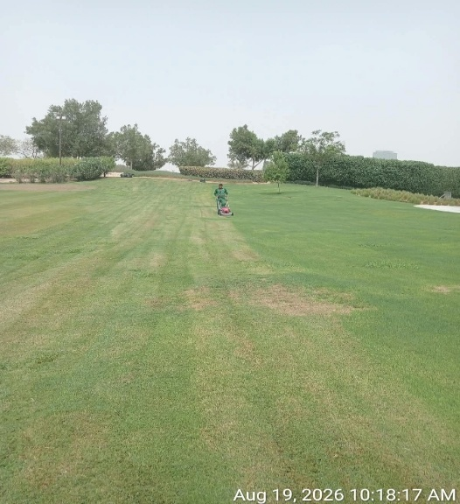 | 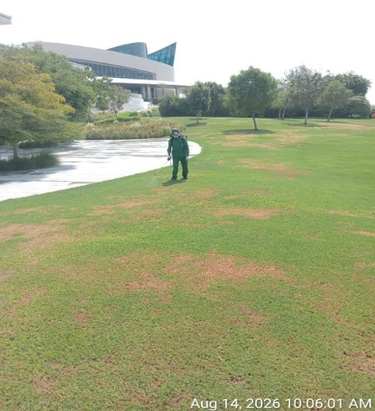 | 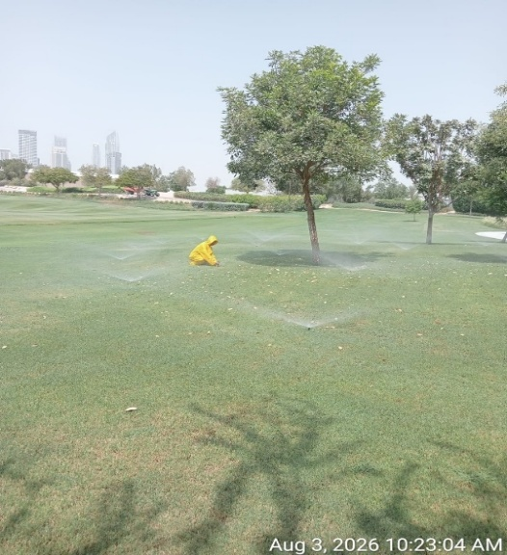

SHRUBS AND GROUNDCOVERS: Trimming & Shaping of Shrubs & Groundcovers, Edging, Gap Filling, Soil Cultivation & Application of Fertilizers & Pesticides as Required Carried out.
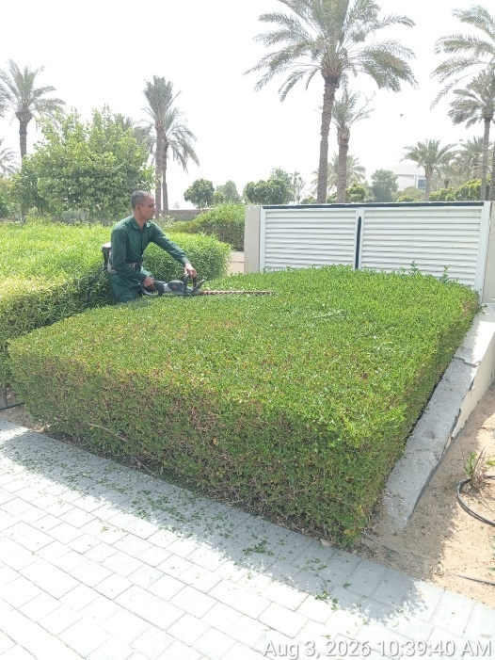 | 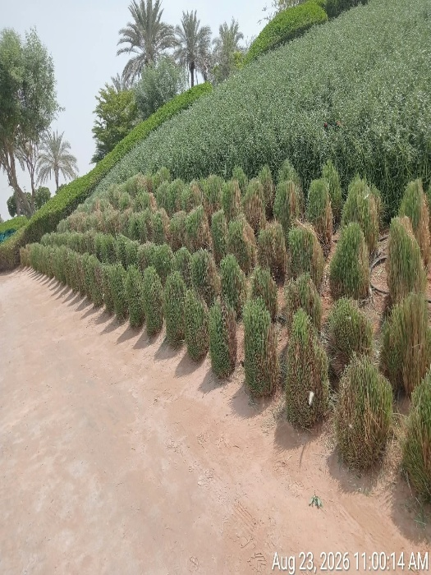 | 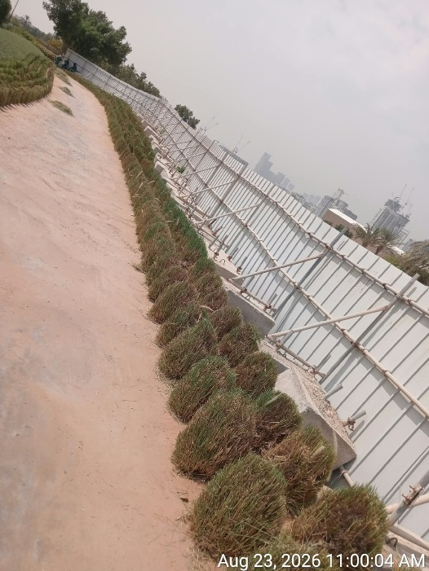
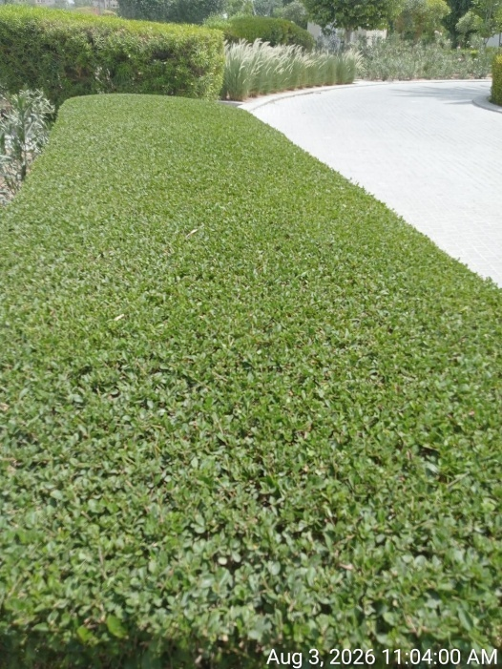 | 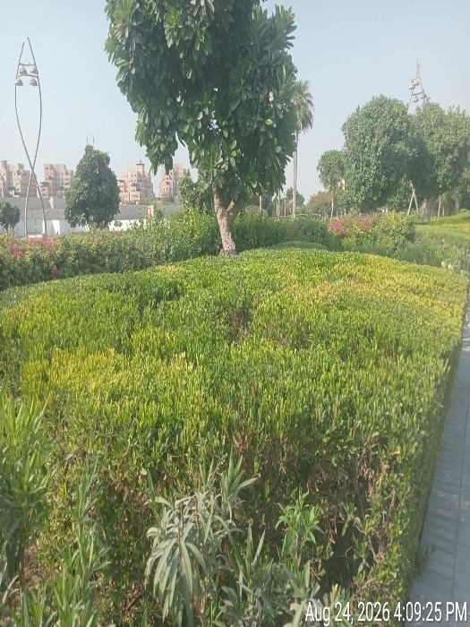 | 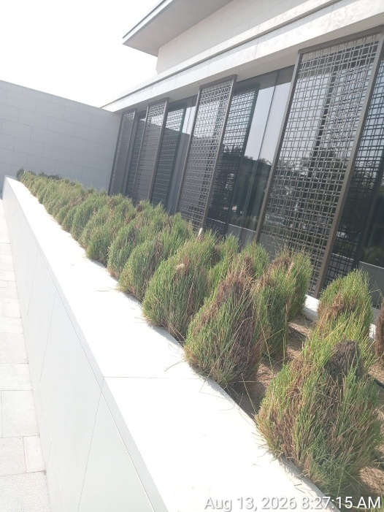
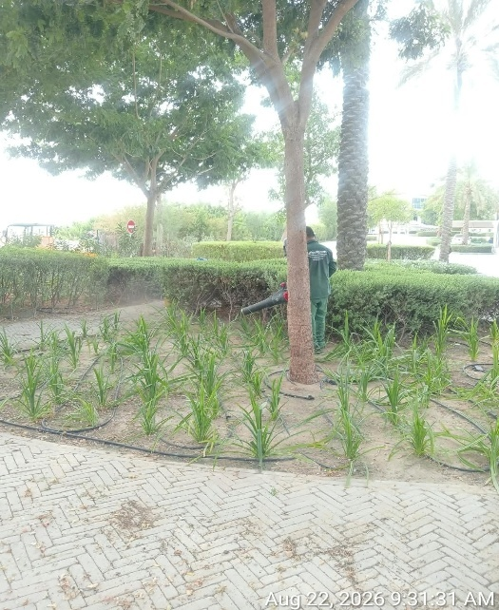 | 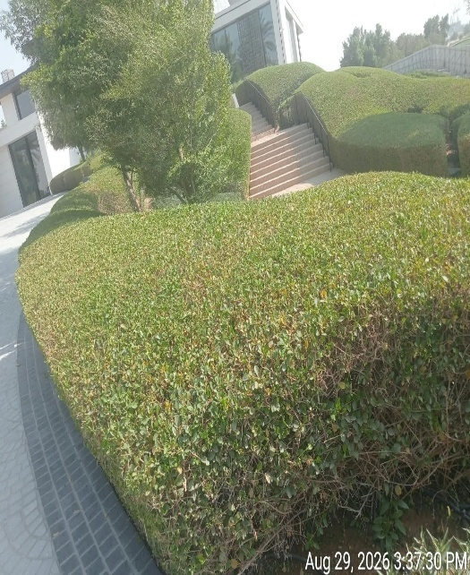 | 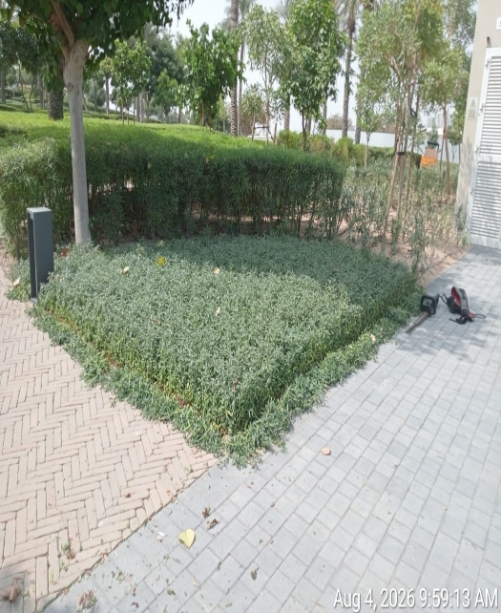
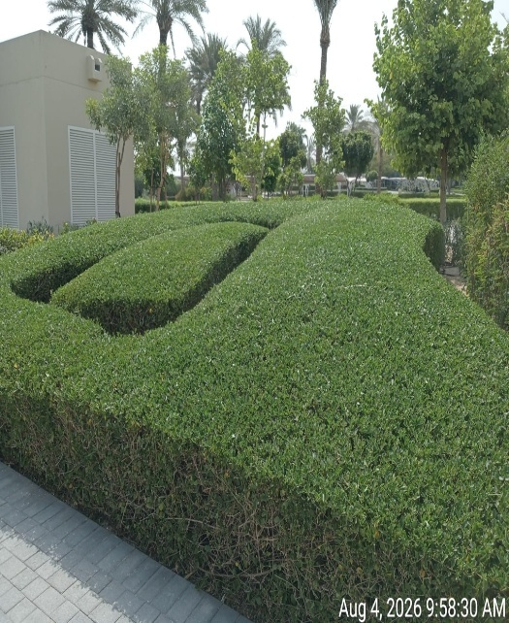 | 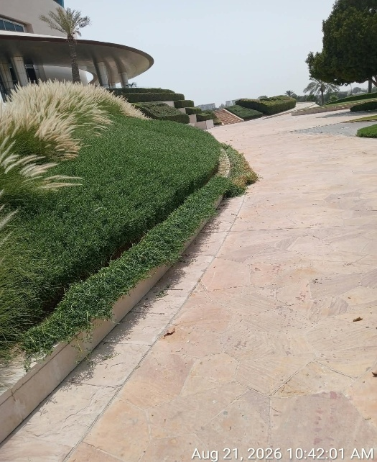 | 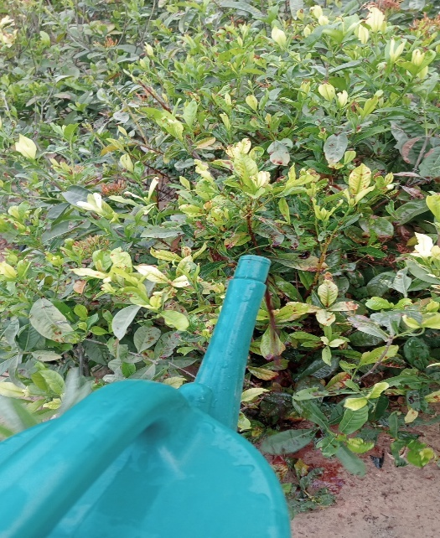
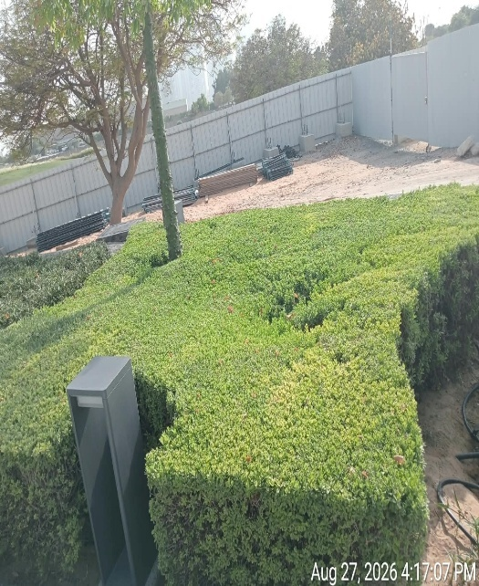 | 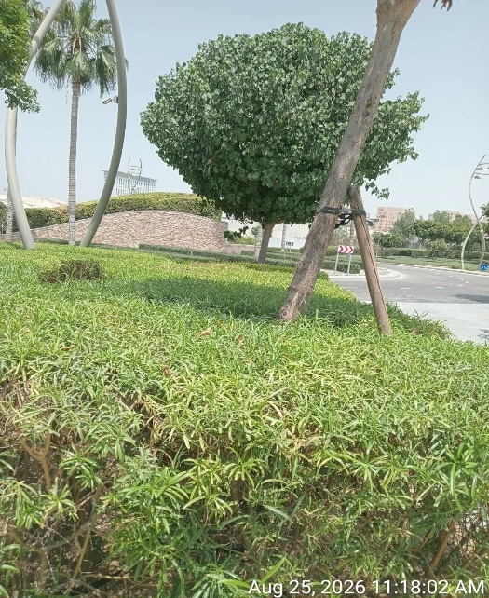 | 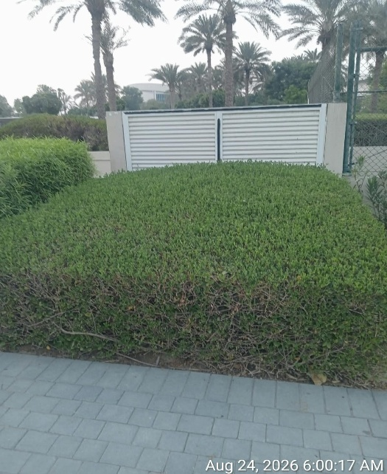

TREES: Thinning, Shaping, Staking & Application of fertilizers have been carried out
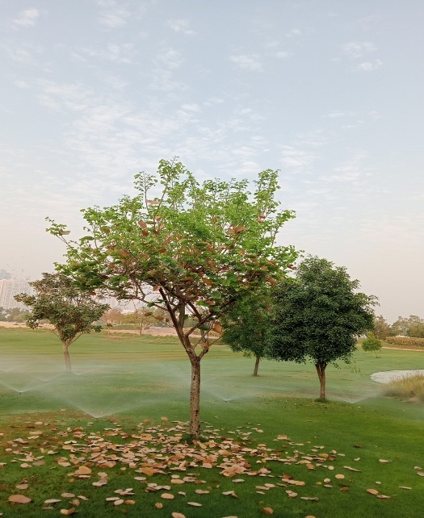 | 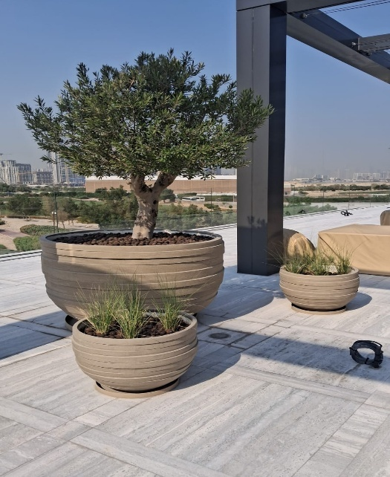 | 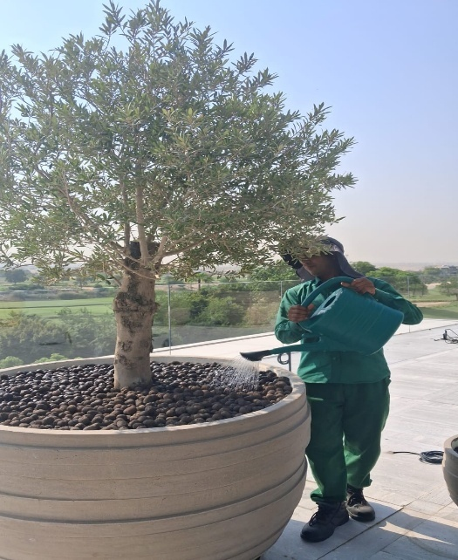
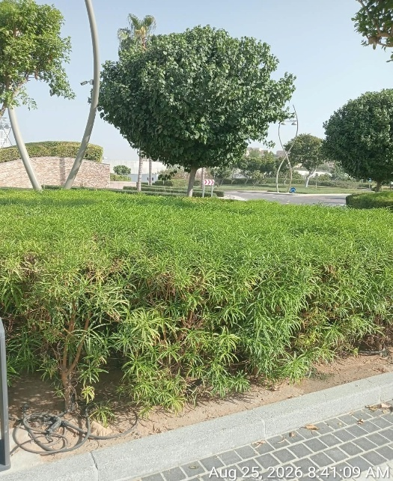 | 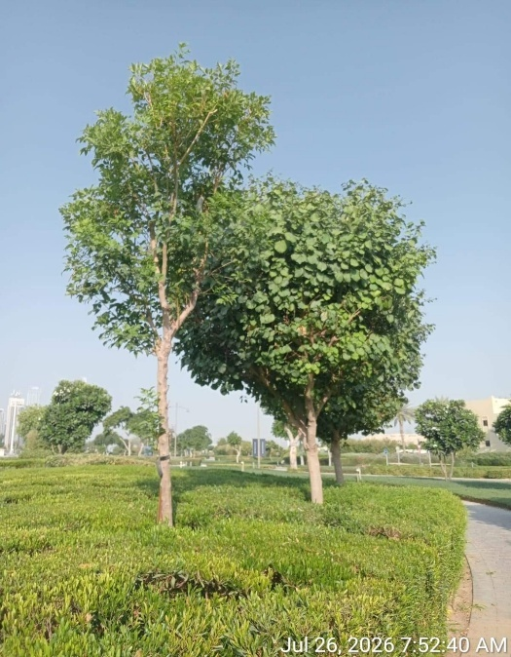 | 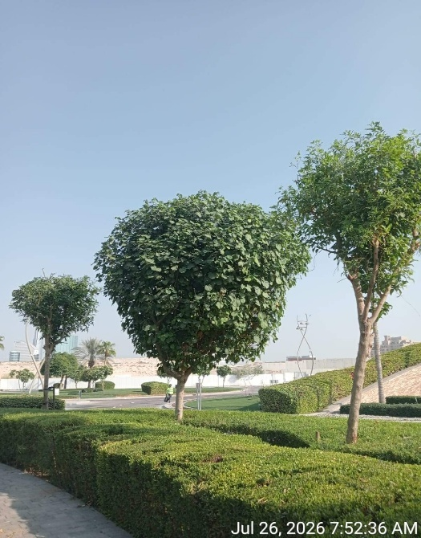
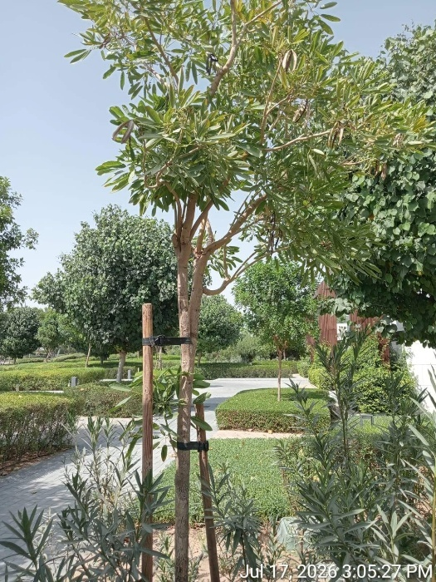 | 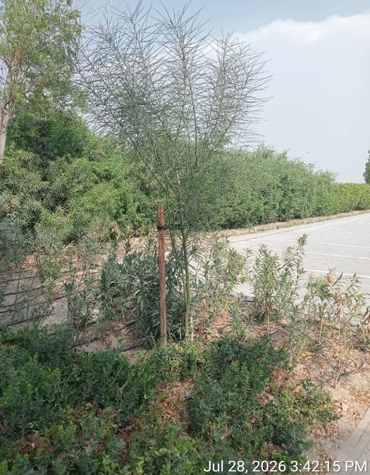 | 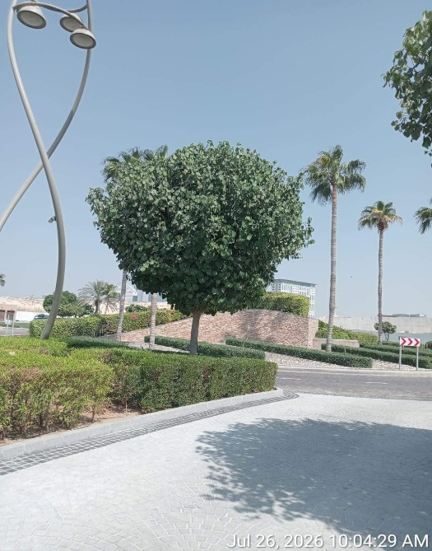

GENERAL MAITENANCE : Cleaning, Washing of the plants, Manual watering, Removal of Dry leaves, Weeding have been carried out.
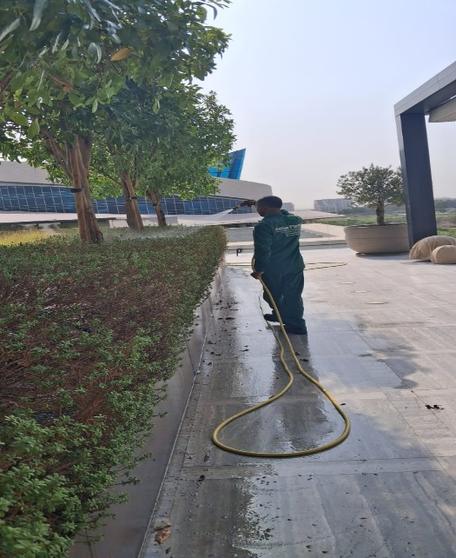 | 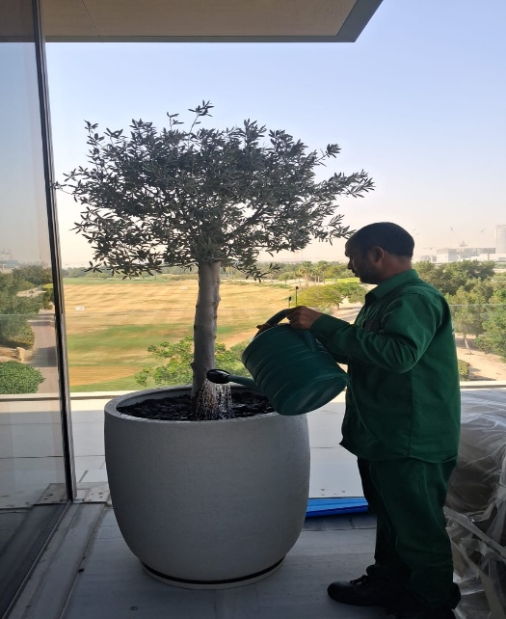 | 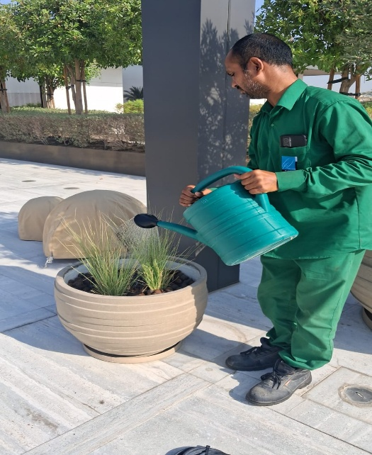
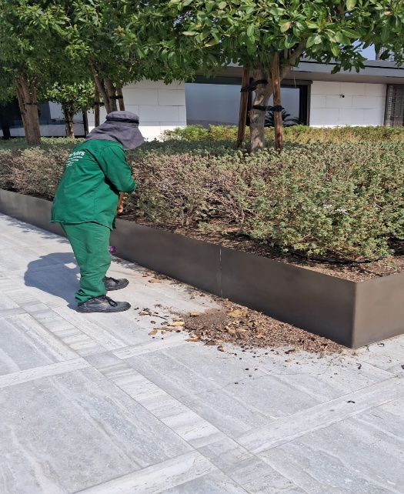 | 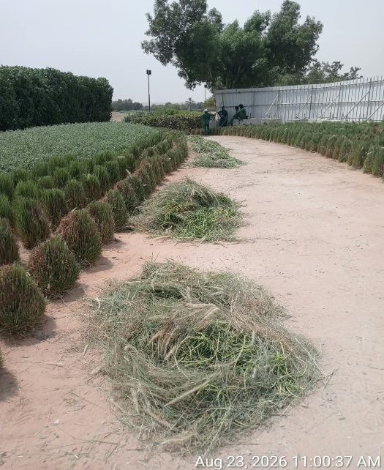 | 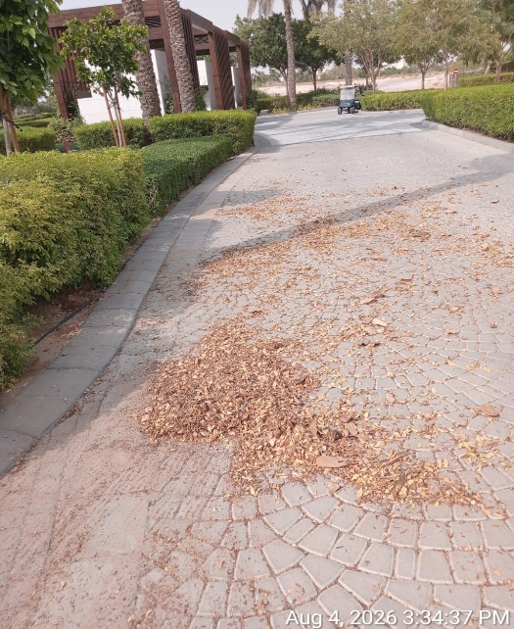
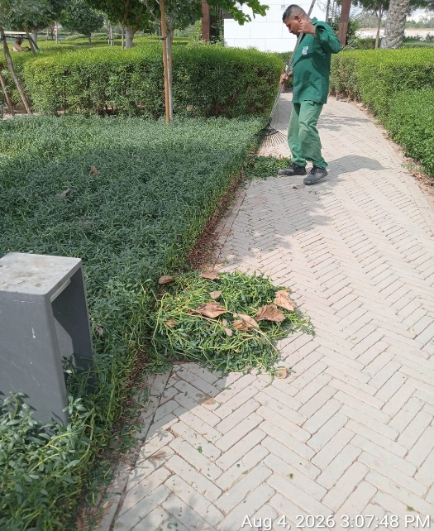 | 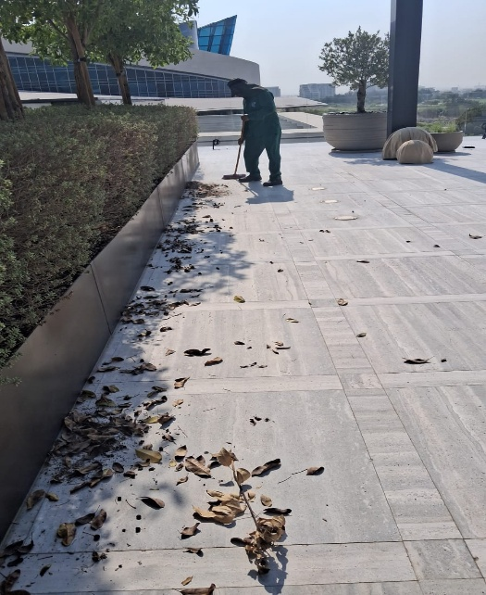 | 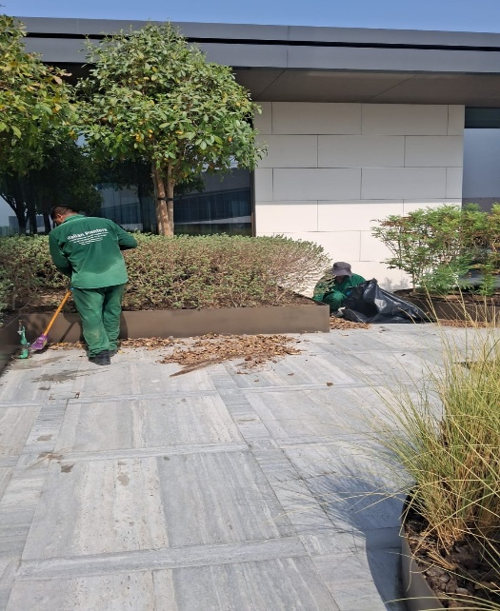
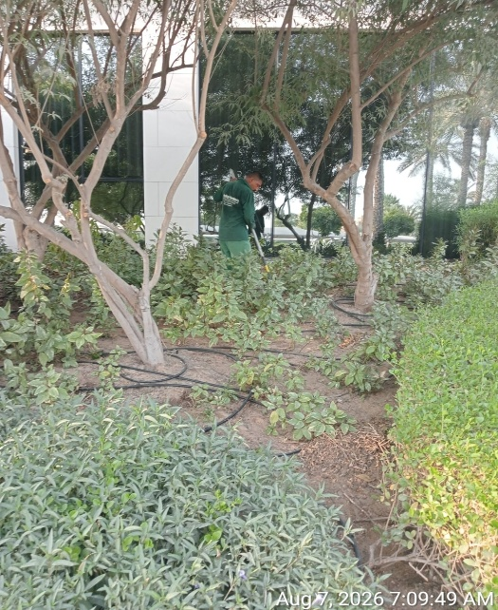 | 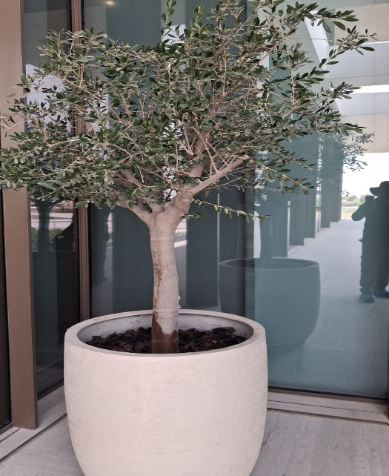 | 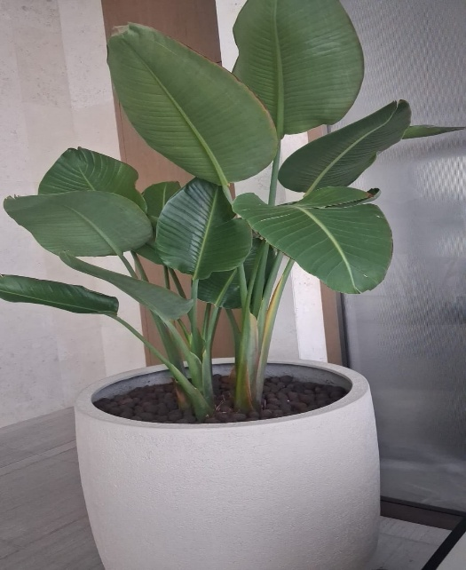
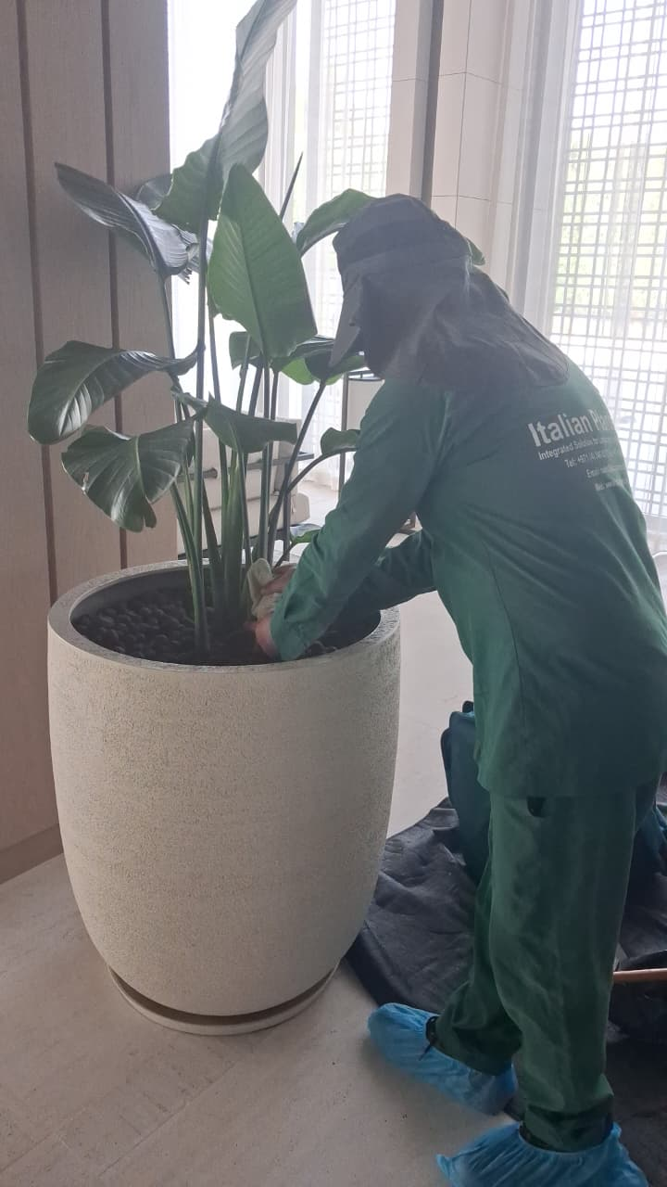 | 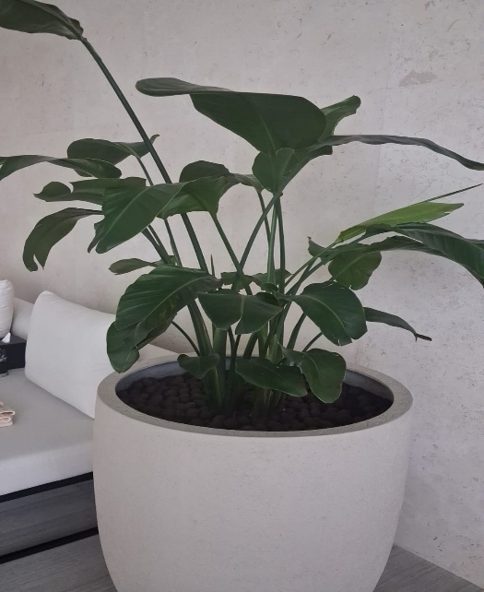 | 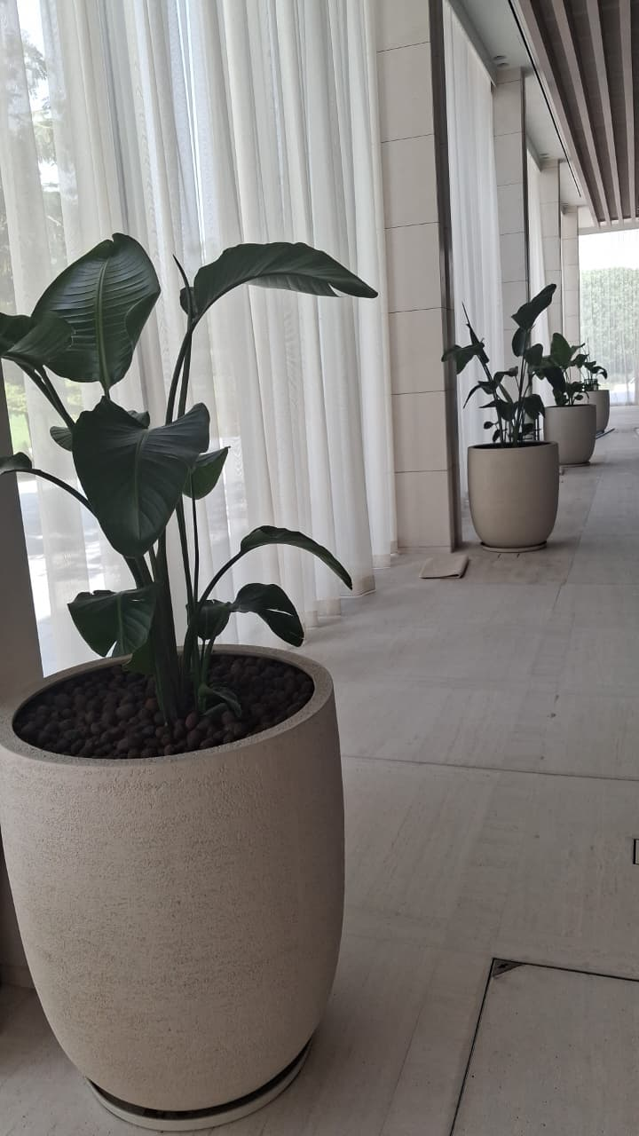

Agriculture Engineer | Basem Adel
Date | 31.08.2026

